Digital Circuits and Systems

Project Report

**Title of the Project : Design a 4-bit synchronous counter in VHDL that counts up or down based on an input control signal and provides an**

**enable feature.**

*Report submitted towards partial fulfilment*

*of Digital Signals and Systems laboratory final project*

by

Rachit Srivastava- Roll No. 23UEC600

Rajat Gupta – Roll No. 23UEC601

Group No. 53

Course Coordinator

Dr. Kanjalochan Jena



Department of Electronics and Communication Engineering The LNM Institute of Information Technology, Jaipur

16 November 2024

Table of Contents

Title of the Project 3

Introduction 3

Project Code 4

RTL Schematic 7

Simulation Timing Diagram 8

Project Summary 9

Constraint File 10

FPGA Board Implementation Results Snapshot 11

Conclusion 14

# Title of the Project

Design a 4-bit synchronous counter in VHDL that counts up or down based on an input control signal and provides an enable feature.

# Introduction

This project involves designing a 4-bit synchronous counter in VHDL, a hardware description language widely used for digital circuit design. The goal is to create a counter that can count up or down based on an input control signal and includes an enable feature to start or stop counting as needed. Synchronous counters are advantageous because all flip-flops are triggered simultaneously by a common clock signal, resulting in reliable, predictable behavior in high-speed applications.

The counter in this project will be implemented with the following key functionalities:

1. **Up Down Count Control**: The counter will count up or down depending on a control input. When the control signal is high, the counter increments; when it is low, the counter decrements.
2. **Enable Control**: An enable signal will control whether the counter is active or paused. When enabled, the counter performs its counting operation; when disabled, it retains its current state.
3. **4-bit Width**: The 4-bit width allows the counter to cycle through values from 0 to 15 in decimal (0000 to 1111 in binary), providing a useful range for various digital applications.

Counters are fundamental components in digital systems, used in timers, event counters, frequency dividers, and many other applications. Designing a flexible and efficient counter in VHDL enhances understanding of synchronous digital design principles and the practical application of VHDL in FPGA and ASIC development. The up/down and enable control features make this counter more versatile and suited to a wider range of applications.

This project is particularly valuable for digital electronics students and professionals, as it combines essential concepts in synchronous design, sequential logic, and VHDL programming, culminating in a functional, adaptable digital circuit design.

# Project Code

library IEEE;  
use IEEE.STD_LOGIC_1164.ALL;  
use IEEE.STD_LOGIC_ARITH.ALL;  
use IEEE.STD_LOGIC_UNSIGNED.ALL;  
  
entity UpDownCounter is  
    Port (  
        clk     : in  STD_LOGIC;                 -- Clock signal  
        rst     : in  STD_LOGIC;                 -- Reset signal (active high)  
        up_down : in  STD_LOGIC;                 -- '1' for up count, '0' for down count  
        en      : in  STD_LOGIC;                 -- Enable signal for counting  
        an      : out STD_LOGIC_VECTOR(7 downto 0); -- Enable signals for 7-segment displays  
        seg     : out STD_LOGIC_VECTOR(6 downto 0)  -- 7-segment display output  
    );  
end UpDownCounter;  
  
architecture Behavioral of UpDownCounter is  
    signal count     : STD_LOGIC_VECTOR(3 downto 0) := "0000";  -- 4-bit counter  
    signal clk_div   : STD_LOGIC_VECTOR(26 downto 0) := (others => '0'); -- Clock divider signal  
    signal slow_clk  : STD_LOGIC := '0';  -- Slow clock generated from clock divider  
  
    -- Function to decode 4-bit count to 7-segment display segments  
    function SevenSegDecoder(input : STD_LOGIC_VECTOR(3 downto 0))  
        return STD_LOGIC_VECTOR is  
    begin  
        case input is  
            when "0000" => return "1000000"; -- Display 0  
            when "0001" => return "1111001"; -- Display 1  
            when "0010" => return "0100100"; -- Display 2  
            when "0011" => return "0110000"; -- Display 3  
            when "0100" => return "0011001"; -- Display 4  
            when "0101" => return "0010010"; -- Display 5  
            when "0110" => return "0000010"; -- Display 6  
            when "0111" => return "1111000"; -- Display 7  
            when "1000" => return "0000000"; -- Display 8  
            when "1001" => return "0010000"; -- Display 9  
            when others => return "1111111"; -- Display off  
        end case;  
    end function;  
  
begin  
    -- Clock divider process to generate a slower clock for counting  
    process(clk)  
    begin  
        if rising_edge(clk) then  
            clk_div <= clk_div + 1;  
            slow_clk <= clk_div(26);  -- Use the MSB as the slower clock  
        end if;  
    end process;  
  
    -- Up/Down counter process with enable functionality  
    process(slow_clk, rst)  
    begin  
        if rst = '1' then  
            count <= "0000";  -- Reset the counter to 0  
        elsif rising_edge(slow_clk) then  
            if en = '1' then  -- Counter only updates when enabled  
                if up_down = '1' then  
                    if count = "1001" then  -- If count reaches 9 (1001 in binary)  
                        count <= "0000";  -- Reset to 0  
                    else  
                        count <= count + 1;  -- Count up  
                    end if;  
                else  
                    if count = "0000" then  -- If count reaches 0  
                        count <= "1001";  -- Reset to 9 (1001 in binary)  
                    else  
                        count <= count - 1;  -- Count down  
                    end if;  
                end if;  
            end if;  
        end if;  
    end process;  
  
    seg <= SevenSegDecoder(count);  
  
    an <= "11111110";  -- Enable the first 7-segment display  
  
end Behavioral;

# RTL Schematic

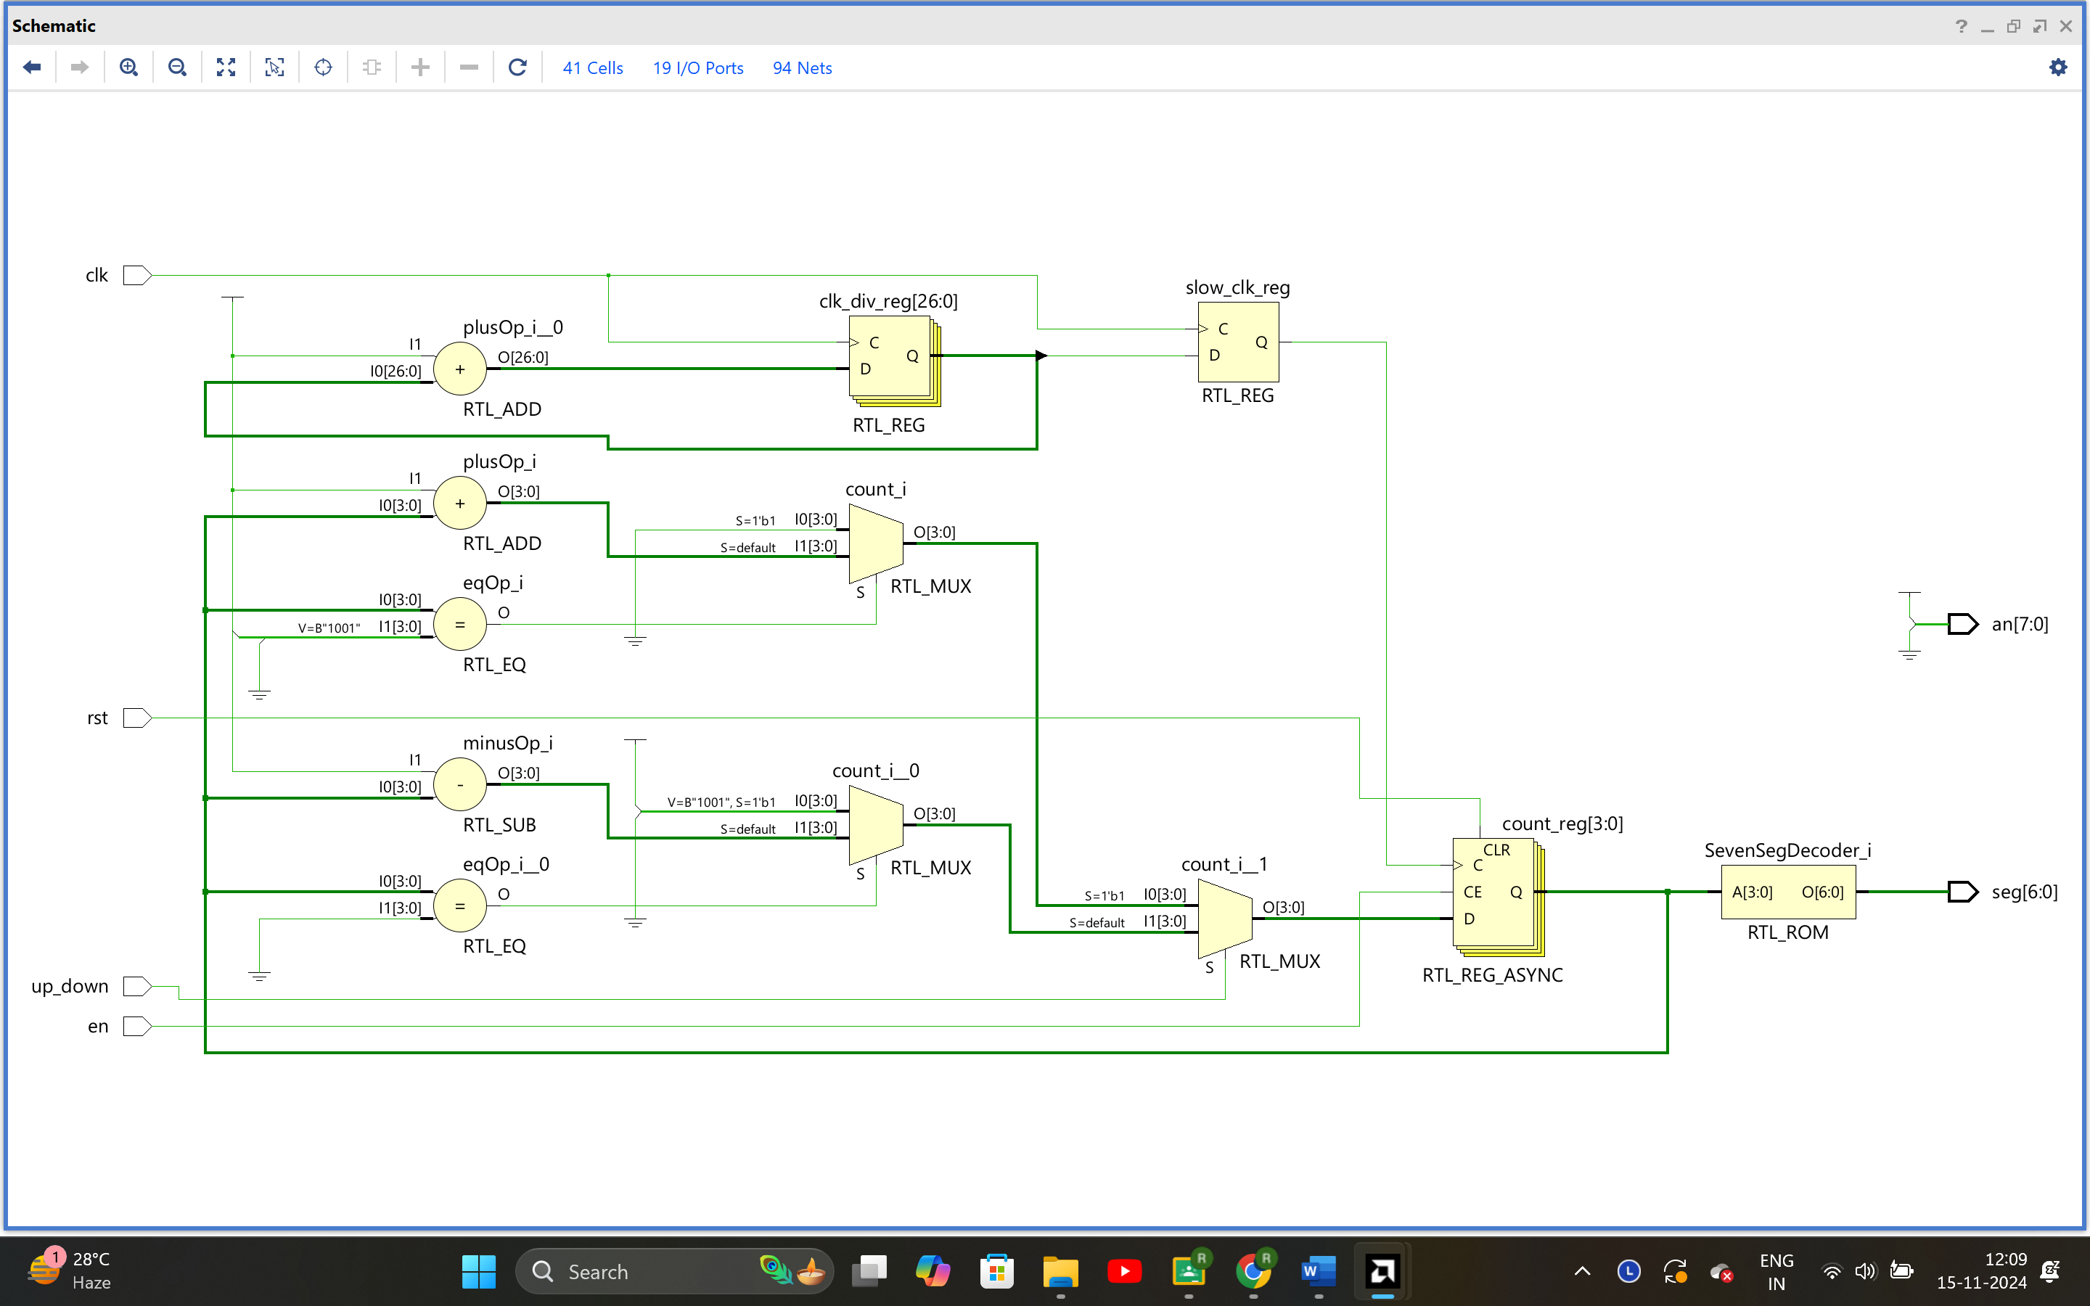

# Simulation Timing Diagram

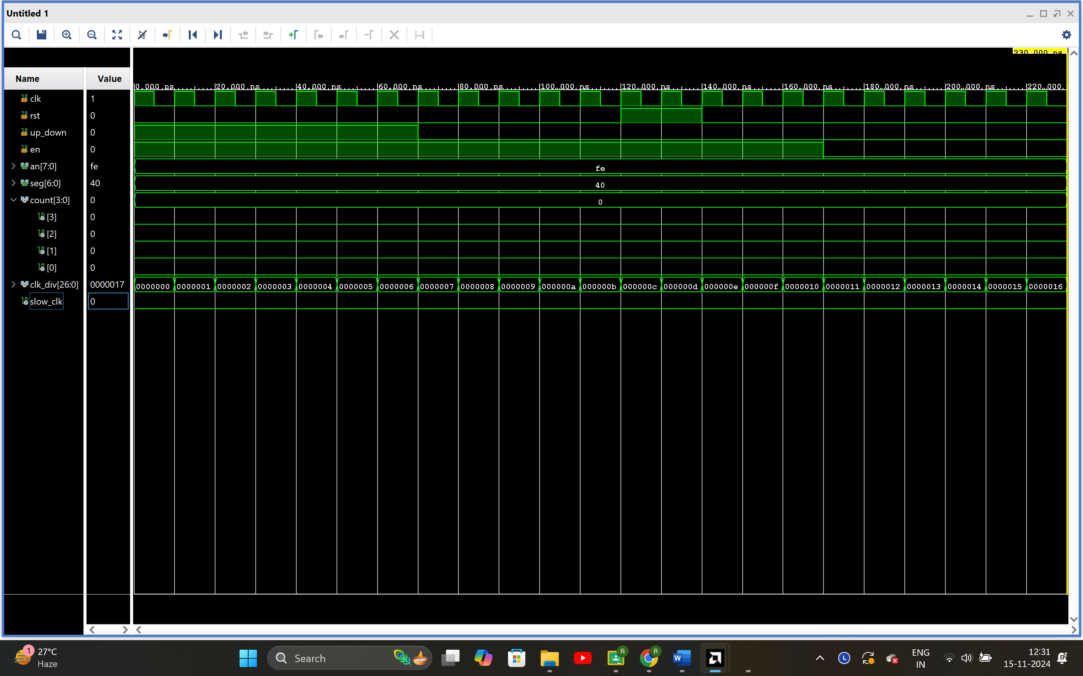

# Project Summary

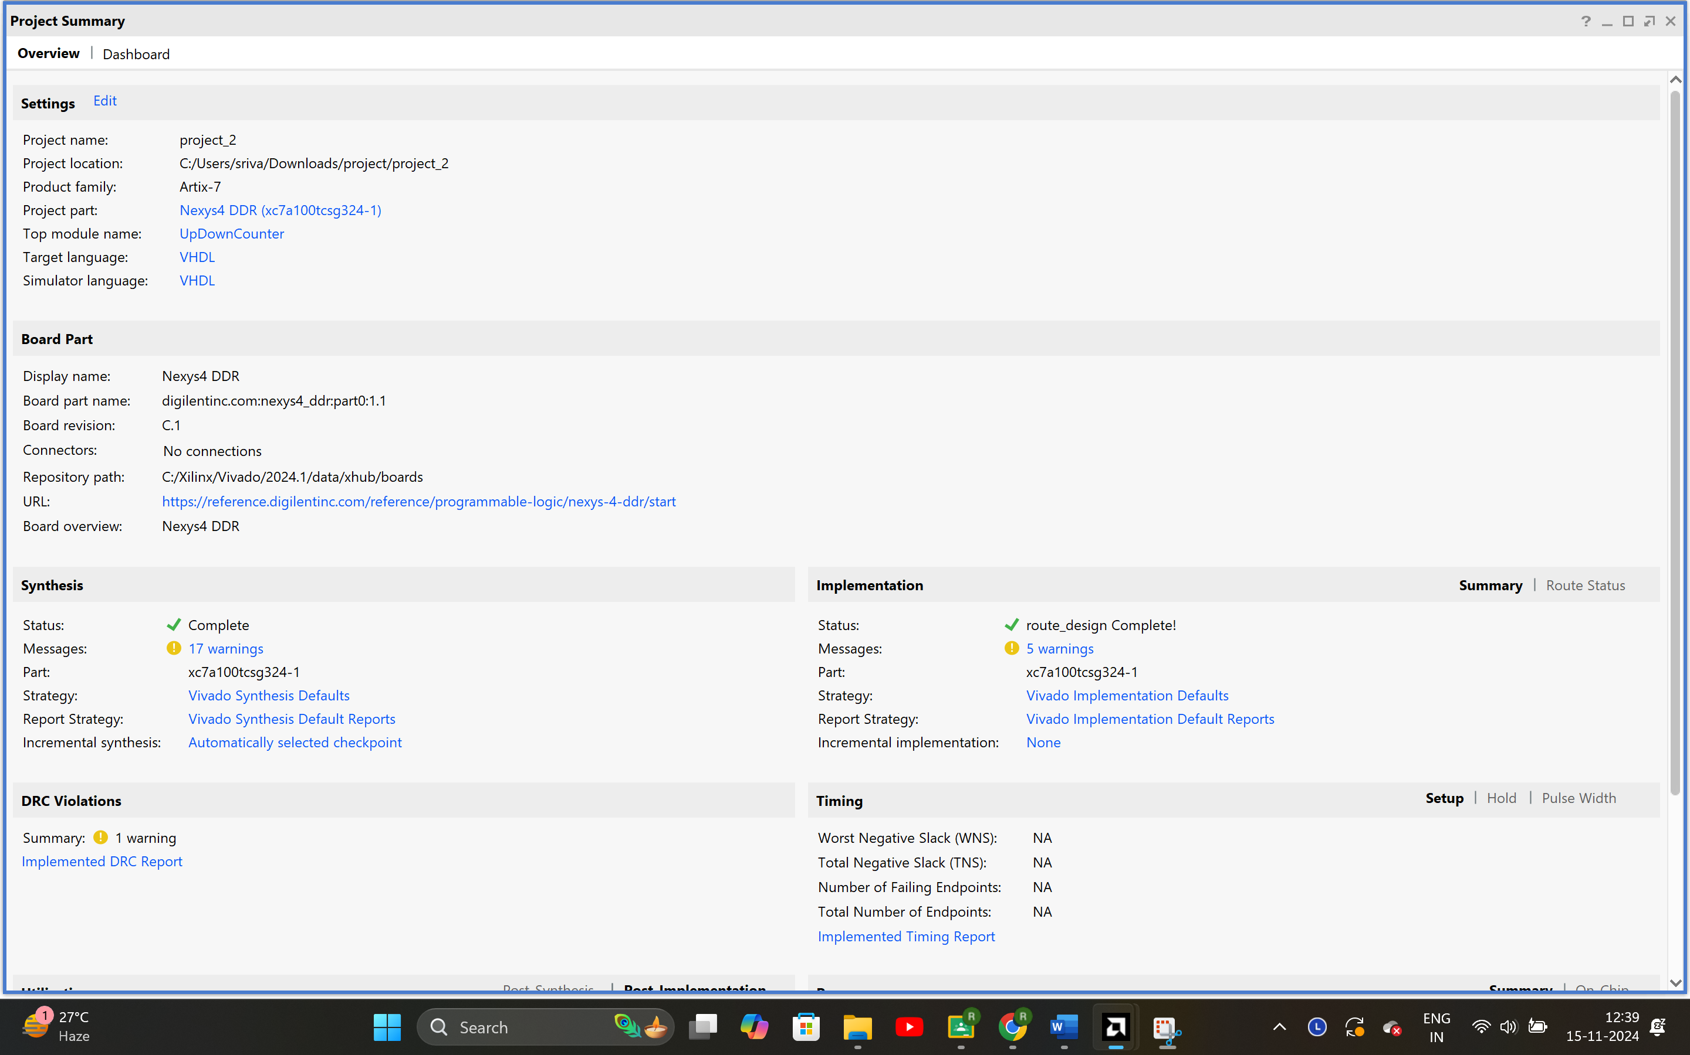

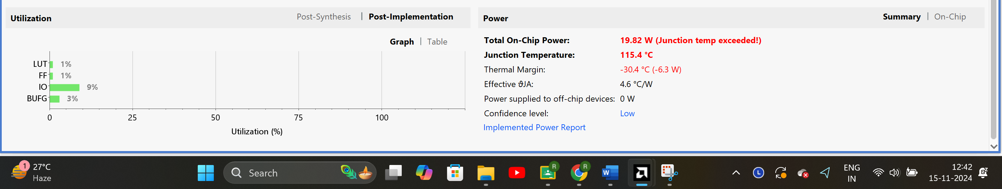

# Constraint File

## Clock Signal

set_property PACKAGE_PIN E3 [get_ports clk]

set_property IOSTANDARD LVCMOS33 [get_ports clk]

## Reset Switch (Assuming using SW0)

set_property -dict { PACKAGE_PIN J15 IOSTANDARD LVCMOS33 } [get_ports { en }]; #IO_L24N_T3_RS0_15 Sch=sw[0]

set_property -dict { PACKAGE_PIN L16 IOSTANDARD LVCMOS33 } [get_ports { up_down }]; #IO_L3N_T0_DQS_EMCCLK_14 Sch=sw[1]

## Reset Button

set_property -dict { PACKAGE_PIN P18 IOSTANDARD LVCMOS33 } [get_ports { rst }]; #IO_L9N_T1_DQS_D13_14 Sch=btnd

## 7-Segment Display Anodes

set_property PACKAGE_PIN U13 [get_ports {an[0]}]

set_property PACKAGE_PIN K2 [get_ports {an[1]}]

set_property PACKAGE_PIN T14 [get_ports {an[2]}]

set_property PACKAGE_PIN P14 [get_ports {an[3]}]

set_property PACKAGE_PIN J17 [get_ports {an[4]}]

set_property PACKAGE_PIN J18 [get_ports {an[5]}]

set_property PACKAGE_PIN T9 [get_ports {an[6]}]

set_property PACKAGE_PIN J14 [get_ports {an[7]}]

set_property IOSTANDARD LVCMOS33 [get_ports {an[*]}]

## 7-Segment Display Segments

set_property PACKAGE_PIN T10 [get_ports {seg[0]}]

set_property PACKAGE_PIN R10 [get_ports {seg[1]}]

set_property PACKAGE_PIN K16 [get_ports {seg[2]}]

set_property PACKAGE_PIN K13 [get_ports {seg[3]}]

set_property PACKAGE_PIN P15 [get_ports {seg[4]}]

set_property PACKAGE_PIN T11 [get_ports {seg[5]}]

set_property PACKAGE_PIN L18 [get_ports {seg[6]}]

set_property IOSTANDARD LVCMOS33 [get_ports {seg[*]}]

# FPGA Board Implementation Results Snapshot

When reset = 0 ; up down = 1 ; enable = 1 :

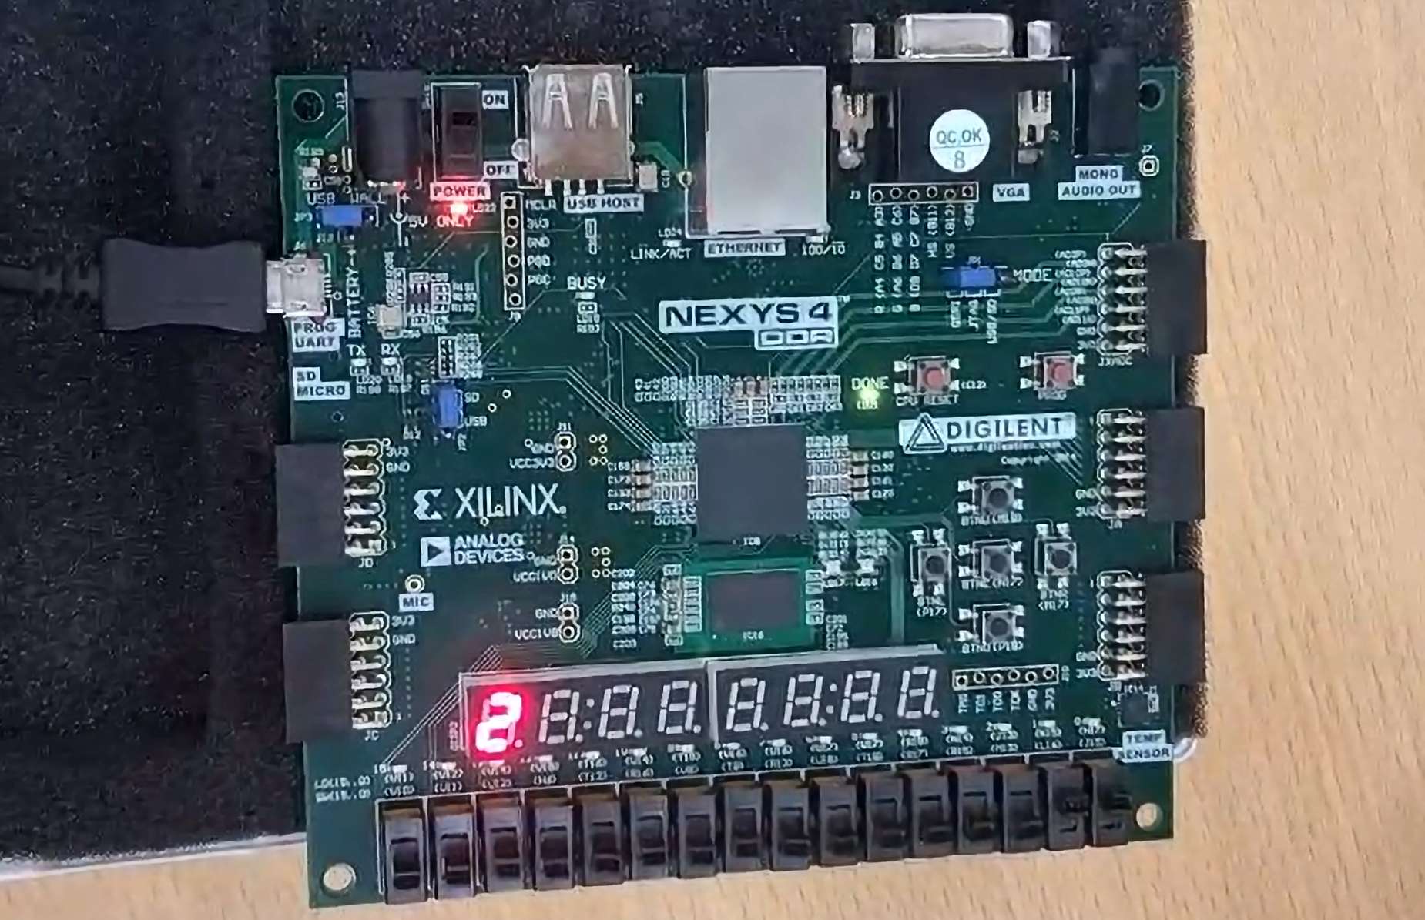

When reset = 0 ; up down = 0 ; enable = 1 :

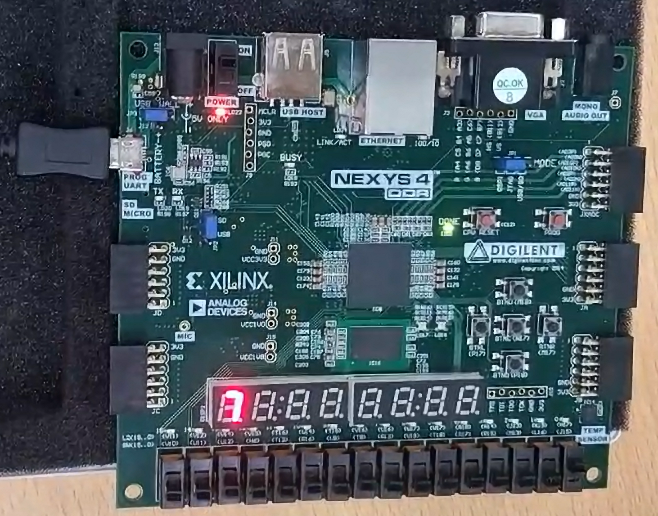

When reset = 1 ; up down = 1 ; enable = 1 :

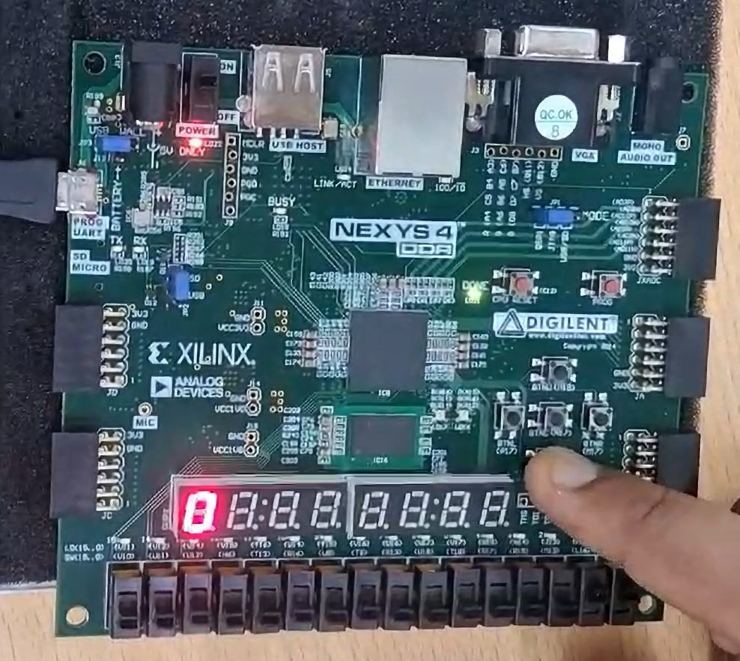

When reset = 1 ; up down = 0 ; enable = 1 :

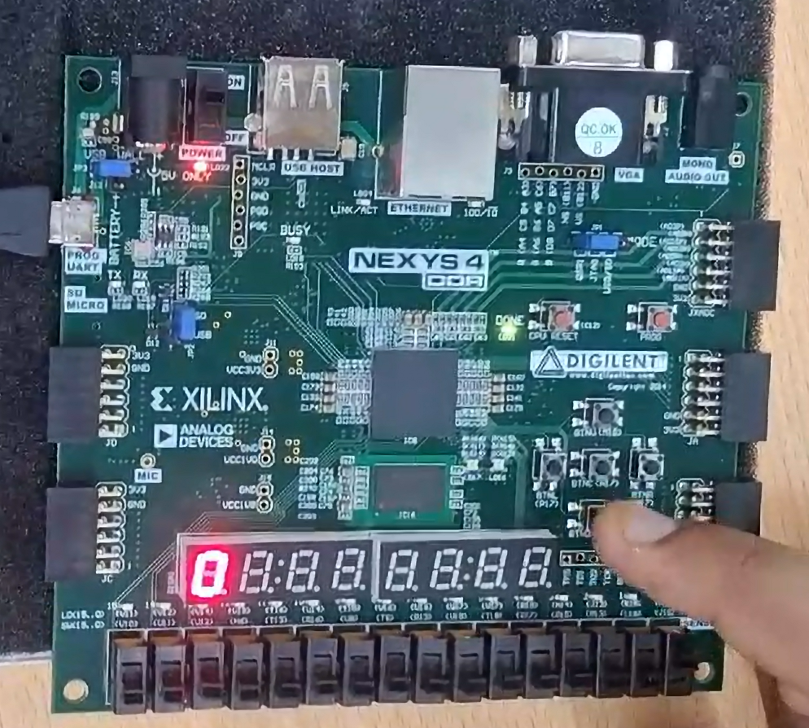

When reset = 0 ; up down = 1 ; enable = 0 :

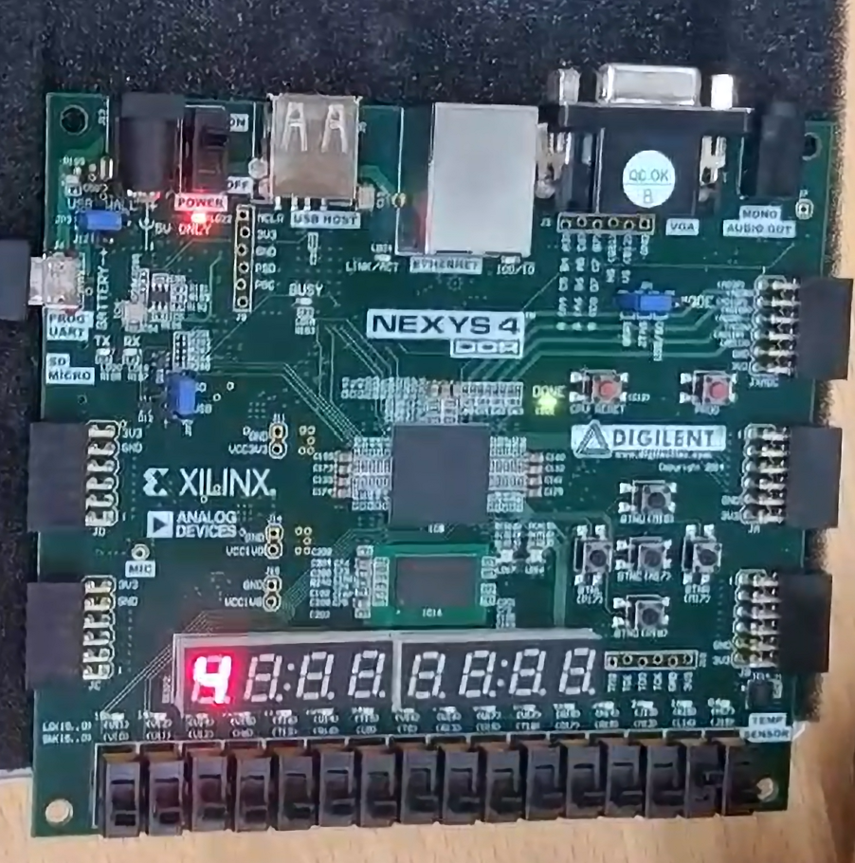

# Conclusion

The VHDL code implements a **4-bit synchronous up/down counter** with additional functionality to control the counting operation. The counter's features include:

1. **Counting Up and Down**:
   * The counter can count up or down based on the up_down signal.
   * It wraps around at the boundaries (0–9 for decimal counting).
2. **Reset Capability**:
   * When the rst signal is asserted (1), the counter is reset to zero.
3. **Enable Control**:
   * The counter increments or decrements only when the en signal is asserted (1), allowing selective activation.
4. **Clock Divider**:
   * A clock divider reduces the frequency of the input clock (clk) to generate a slower clock (slow_clk), enabling easier observation of the counter's behavior.
5. **7-Segment Display Integration**:
   * The counter's output is decoded into a format compatible with a 7-segment display using the SevenSegDecoder function.
   * The first display in the 7-segment module is enabled using the an signal.

|  |  |  |
| --- | --- | --- |
| **Name of Entity** | **No. of LUT used** | **Total On Chip Power** |
| 4-bit synchronous counter having enable and up down counter | 1 | 19.82W |